USGS Interferometric Synthetic Aperture Radar (IFSAR) Alaska

https://lta.cr.usgs.gov/IFSAR_Alaska
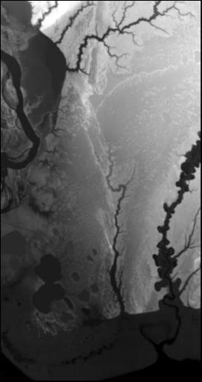
The U.S. Geological Survey (USGS) National Geospatial Program (NGP) developed the Alaska Mapping Initiative (AMI) to collaborate with State and other Federal partners in Alaska to acquire 3-dimensional elevation data to improve statewide topographic mapping products. AMI coordinates Federal activities through the Alaska Mapping Executive Committee (AMEC) and State efforts through Alaska’s Statewide Digital Mapping Initiative (SDMI) to ensure a unified approach for consistent data acquisition and enhancement of elevation data products.
AMI attained interferometric synthetic aperture radar (IFSAR) data to generate Digital Elevation Models (DEMs). This radar mapping technology is an effective tool for collecting data under challenging circumstances such as cloud cover, extreme weather conditions, rugged terrain, and remote locations. Airborne IFSAR data were flown over south-central Alaska in summer 2010 and over northwestern Alaska in 2012. Additional areas may become available as projects are inspected for quality and released for dissemination. A coverage map in EarthExplorer indicates the extent of distributable data.

Susitna Flats State Game Refuge (July 2010)

IFSAR Alaska Products
- Elevation products generated from IFSAR data include Digital Surface Model (DSM) and Digital Terrain Model (DTM) data.
- DSMs provide elevation values of landscape features on the earth's surface. This topographic product contains the height of the highest surface on the ground including vegetation, man-made structures, and bare earth.
- DTMs provide elevation values of the underlying terrain of the earth’s surface. This topographic product reflects the height of bare earth where the elevations of vegetation and man-made features have been removed.
- The USGS Earth Resources Observation and Science (EROS) Center distributes IFSAR Alaska products in Georeferenced Tagged Image File Format (GeoTIFF). The pixel values for the grayscale images represent elevation numbers.
Product Specifications
Projection | Alaska Albers Conical Equal Area
Horizontal Datum | NAD83
Vertical Datum | NAVD88
Vertical Units | Meters
Post Spacing | 5-meter
Vertical Accuracy | 3-meter Confidence Level of 90% for a 0-10 degree slope
Horizontal Accuracy | 12.2-meter Circular Error of 90% (CE90) 13.9-meter Circular Error of 95% (CE95) 5.682-meter Root Mean Square Error (RMSE) for x and y
Raster Size | 15 minute tiles
File Size | 50 - 100 megabytes
DEM products meet the horizontal accuracy requirements for USGS maps and orthophotos at 1:24,000-scale.

Coverage Maps
Coverage Maps indicating the availability of IFSAR Alaska products are available for download.
- Download shapefile - http://dds.cr.usgs.gov/ee-data/coveragemaps/shp/ee/ifsar/ifsar.zip
- Download kml - http://dds.cr.usgs.gov/ee-data/coveragemaps/kml/ee/ifsar.kml
- Product Info
- Get Data
- Policies
- Help

Additional Information:
- USGS Alaska Mapping Initiative – nationalmap.gov/alaska/
- Alaska’s Statewide Digital Mapping Initiative – www.alaskamapped.org/dem
- Alaska Mapping Executive Committee – nationalmap.gov/alaska/about_ak_excomm.html
- USGS Factsheet - The 3D Elevation Program – Summary for Alaska – pubs.usgs.gov/fs/2013/3083/pdf/fs2013-3083.pdf

