HYDROGRAPHIC SERVICES REVIEW PANEL
A federal advisory committee, advising the NOAA Administrator
DRAFT FOR REVIEW / DISCUSSION – 27Feb2019
NOAA’s National Ocean Service Role in the U.S. Maritime Arctic

ARCTIC OBJECTIVES
The reduction of ice in U.S. Arctic waters is opening a new maritime frontier in Alaska. This change represents a significant opportunity for benefiting the nation’s blue economy by providing improved access to raw materials as well as access to domestic and foreign markets. It also provides shorter and more fuel-efficient shipping routes. There are efficiencies to be realized in this new frontier, but they must be approached cautiously and with international agreement to ensure they are conducted safely and in an environmentally sound manner as to not disrupt the pristine environment and rich cultural heritage that have always defined the arctic. International attention has been focused on the increase in maritime operations in Arctic waters to ensure they are conducted in a safe and environmentally sound manner and do not negatively impact Arctic communities and their residents’ way of life. To that end the International Maritime Organization promulgated the Polar Code for vessels in order to target the safety and environmental protection issues unique to Arctic maritime operations. NOAA’s National Ocean Service must provide the necessary navigation services that will enable this Arctic frontier to grow in a responsible manner.

UNIQUE CHALLENGES IN ARCTIC WATERS
- Limited infrastructure and communications in the region complicate the execution of NOAA’s traditional missions.
- The vastness, remoteness and seasonal ice conditions force shorter hydrographic survey seasons and present unique mobilization and cost challenges for NOAA’s hydrographic surveys by both NOAA and NOAA’s contract partners.
U.S.
Russia
- Oil spill response has limited effectiveness in arctic conditions. Emphasis must be placed on prevention of marine casualties in order to protect the sensitive and fragile Arctic marine environment.
- Safety and environmental issues are seasonal and dynamic. These include but are not limited to the presence of ice, marine mammals, and indigenous subsistence hunters.
Maritime Traffic in the Bering Strait in 2018

DESIRED NAVIGATIONAL SERVICES IN ARCTIC WATERS

- A robust geospatial and oceanographic infrastructure to support nautical charting by and providing accurate positioning services and water levels along the coasts of the Chukchi and Beaufort Seas. This includes addressing gaps in geodetic coverage, tides and currents, hydrographic surveys and shoreline mapping – the foundational data building blocks for providing accurate nautical charts.
DESIRED NAVIGATIONAL SERVICES IN ARCTIC WATERS (Cont’d)

- 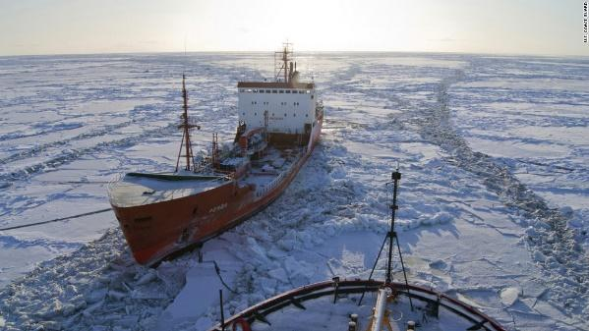Real time information via observations or verified models on environmental conditions to aid safe vessel transits and operations.
- Easy identification and communication between all maritime users by employing emerging electronic navigation technologies including but not limited to Automatic Identification System (AIS) on vessels to transmit environmental and safety information to vessels operating in Arctic waters.
- Provide accurate navigational charts developed from hydrographic surveys of waters where vessels operate.

- Prioritization of hydrographic surveys and higher resolution navigational charts based on historic vessel tracks and planned future development to promote growth in Alaska’s blue economy.
- Use of electronic navigation eNav technologies that mitigate the lack of infrastructure by transmitting virtual aids to navigation to notify mariners of routing schemes and navigational hazards.
RECOMMENDATIONS FOR NOAA ACTION

- Evaluate areas of the Arctic where tidal and geospatial Physical Oceanographic Real Time System (PORTS) sensors can be installed to provide foundational data for charting as well as additional information to mariners that enhance maritime safety and environmental protection.
- Partner with the U.S. Coast Guard to expand the dissemination of NOAA environmental and safety information to vessels via AIS transmitters and other emerging communications technologies the Coast Guard has available or is developing.
- Develop a dynamic electronic Coast Pilot for Arctic waters to more effectively provide relevant and current information to mariners navigating Arctic waters.
- Prioritize NOAA and NOAA contracted hydrographic surveys and production of accurate, updated navigational charts through review of historical vessel tracking information on vessels transiting Arctic waters obtained from AIS monitoring systems.

In October 2003, Secretary of Commerce Don Evans established the Hydrographic Services Review Panel as directed by the Hydrographic Services Improvement Act of 2002, Public Law 107-372. Panel members, appointed by the NOAA Administrator, include a diverse field of experts.
PUBLIC MEMBERS 2019

Dr. Larry Atkinson  Capt. Anuj Chopra  Mr. Sean M. Duffy, Sr.  Mr. Lindsay Gee  Ms. Kim Hall | Ms. Deanne Hargrave  Mr. Edward Kelly  Capt. Ann Kinner  Dr. David F. Maune  Capt. Anne McIntyre | Captain Ed Page (USCG Ret)  Capt. Salvatore Rassello  Mr. Edward J. Saade (Chair)  Ms. Julie Thomas (Vice Chair)  Mr. Gary Thompson

